**Title : Operating Systems Assignment - 1: Unix Commands**

**Name : Tanishq Thuse**

**Branch - CSE(AI)**

**Div - B**

**Guide : Archana Ma’am**

I have written these commands on my fedora distro laptop

**Q1)Change your password to a password you would like to use for the remainder of the semester.**

**Command : passwd**

**Output Screenshot :** 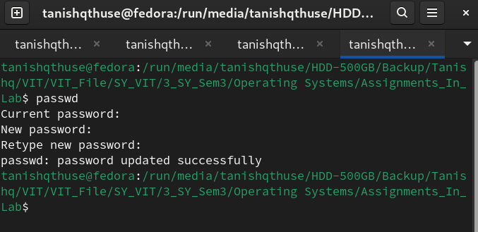

**Q2) Display the system’s date.**

**Command : date , Output :** 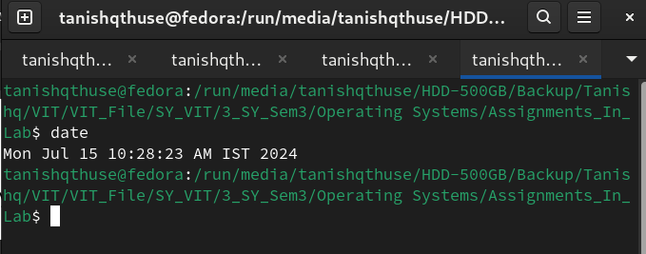

**Q3) Count the number of lines in the /etc/passwd file.**

**Command : wc -l /etc/passwd**

**Output :**

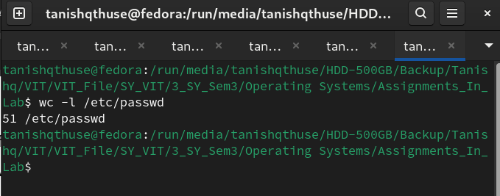

**Q4) Find out who else is on the system.**

**Command : who**

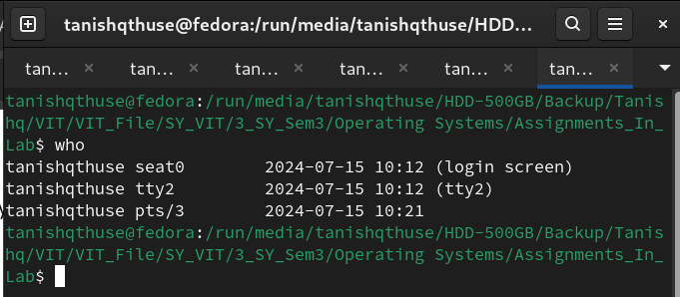

**Q5) Direct the output of the man pages for the date command to a file named mydate.**

**Command : touch mydate; man date > mydate ;cat mydate**

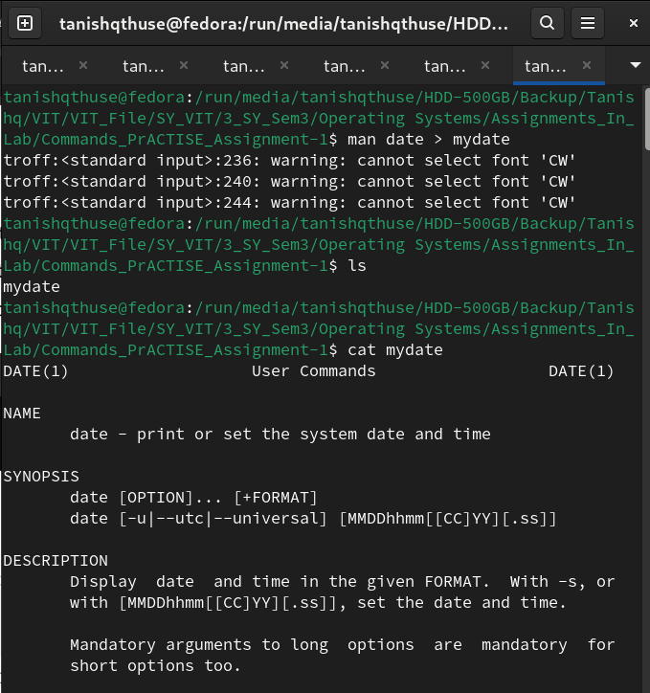

**Q6)Create a subdirectory called mydir.**

**Command : mkdir mydir**

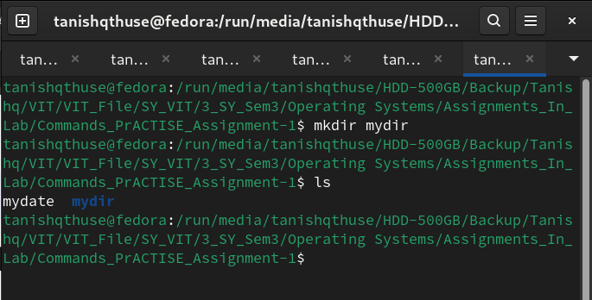

**Q7) Move the file mydate into the new subdirectory.**

**Command : mv mydate mydir/**

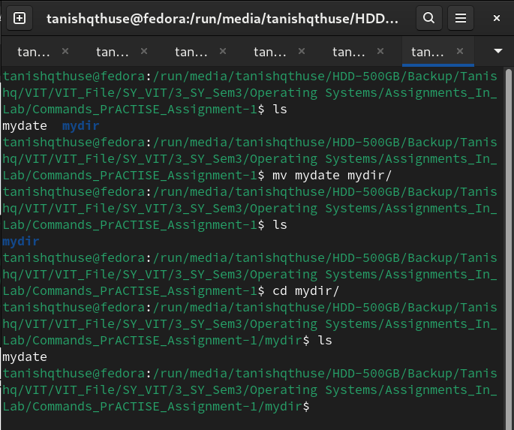

**Q8) Go to the subdirectory mydir and copy the file mydate to a new file called ourdate**

**Command : cp mydate ourdate**

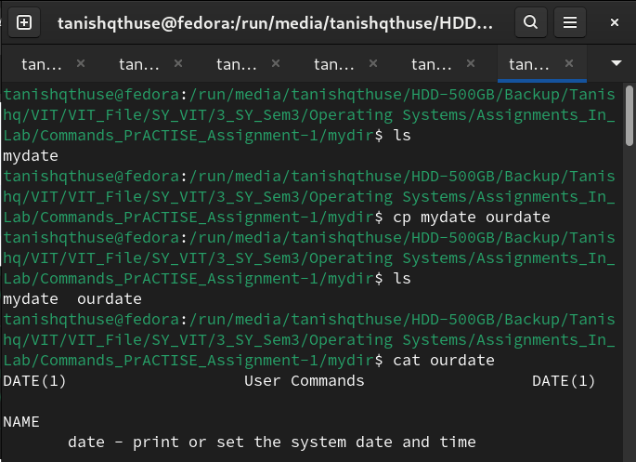

**Q9) List the contents of mydir.**

**Command : ls**

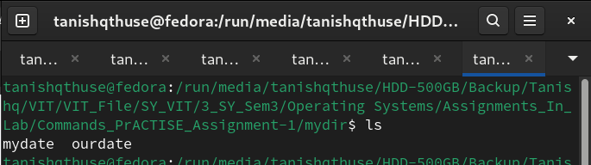

**Q10)Do a long listing on the file ourdate and note the permissions.**

**Command : ls -l ourdate**

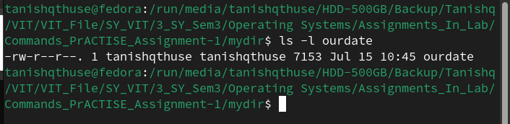

**Q11) Display the name of the current directory starting from the root.**

**Command : pwd (starting from root)**



**Q12) Move the files in the directory mydir back to your home directory.**

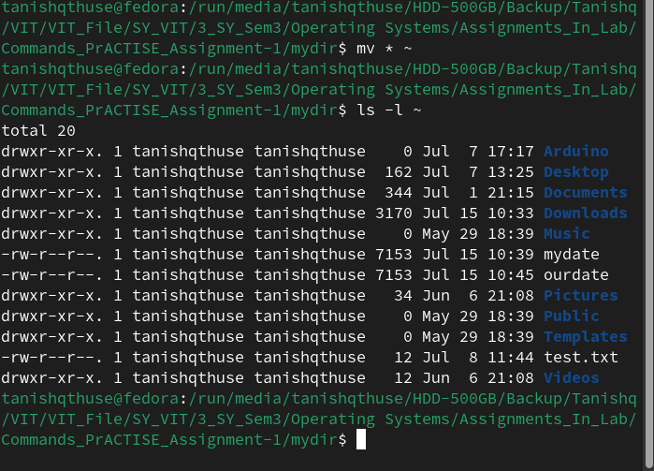

**Q13)Display the first 5 lines of mydate.**

**Command : head -n 5 mydate**

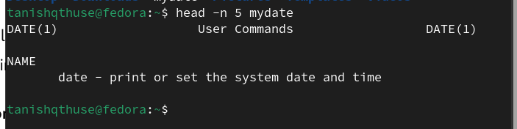

**Q14)Display the last 8 lines of mydate.**

**Command : tail -n 8 mydate**

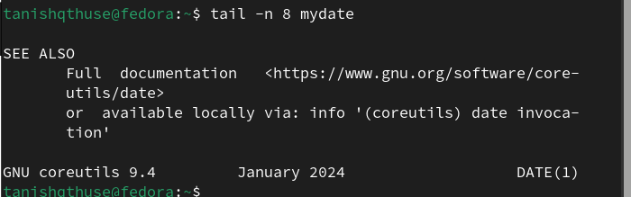

**Q15)Remove the directory mydir.**

**Command : rmdir mydir/**

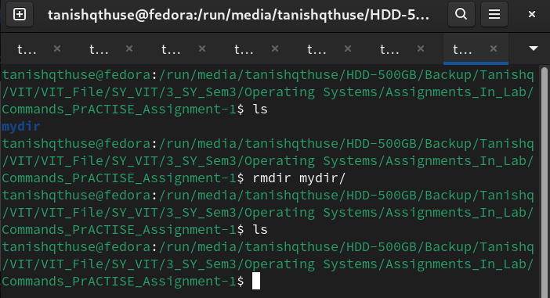

**Q16)Redirect the output of the long listing of files to a file named list.**

**Command : ls -l > list**

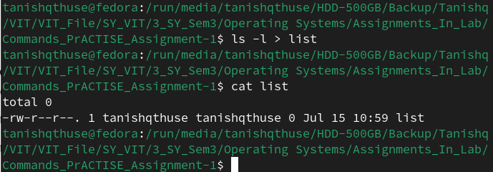

**Q17)Select any 5 capitals of states in India and enter them in a file named capitals1. Choose 5 more capitals and enter them in a file named capitals2. Choose 5 more capitals and enter them in a file named capitals3. Concatenate all 3 files and redirect the output to a file named capital**

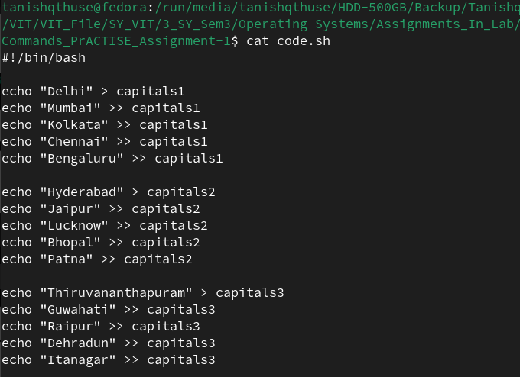

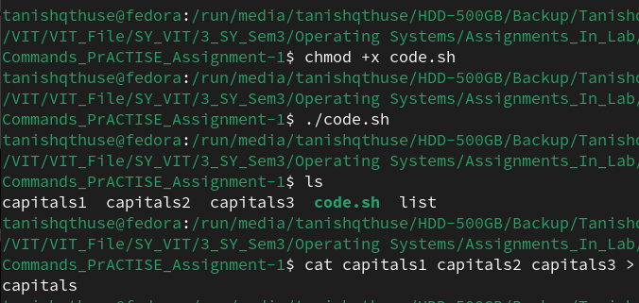

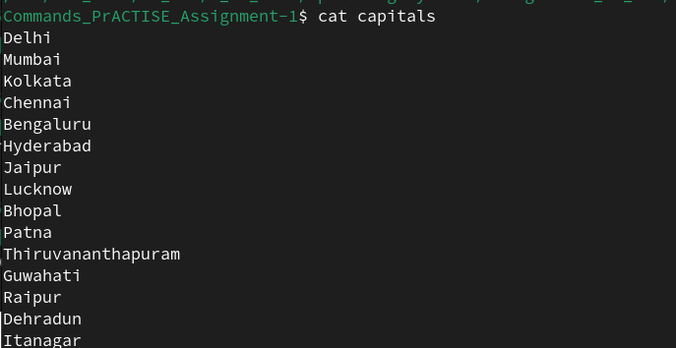

**Q18) Concatenate the file capitals2 at the end of file capitals.**

**Command : cat capitals2 >> capitals**

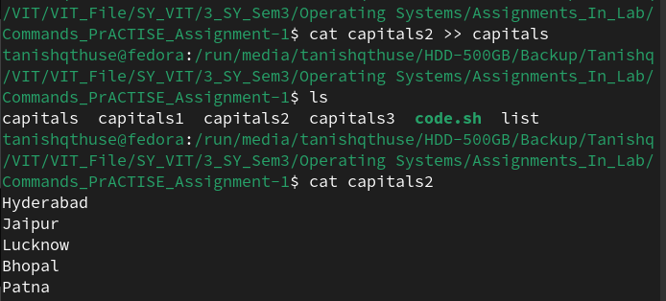

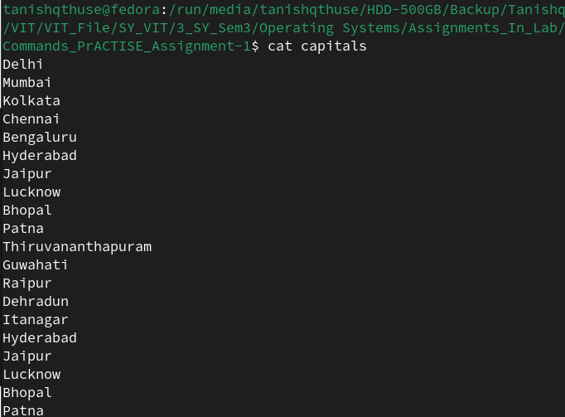

**Q19)Give read and write permissions to all users for the file capitals.**

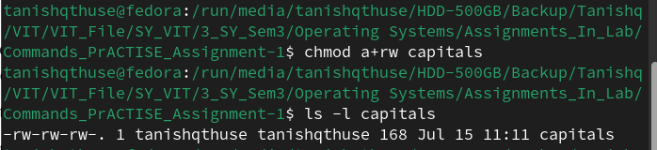

**Q20)Give read permissions only to the owner of the file capitals. Open the file, make some changes and try to save it. What happens ?**

**Command : chmod 400 capitals**

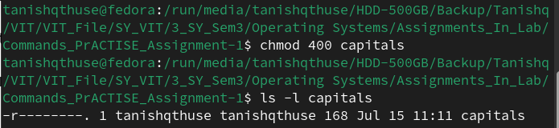

**Q21) Create an alias to concatenate the 3 files capitals1, capitals2, capitals3 and redirect the output**

**to a file named capitals. Activate the alias and make it run.**

**Command : nano ~/.bashrc**

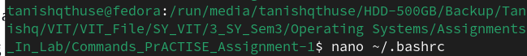

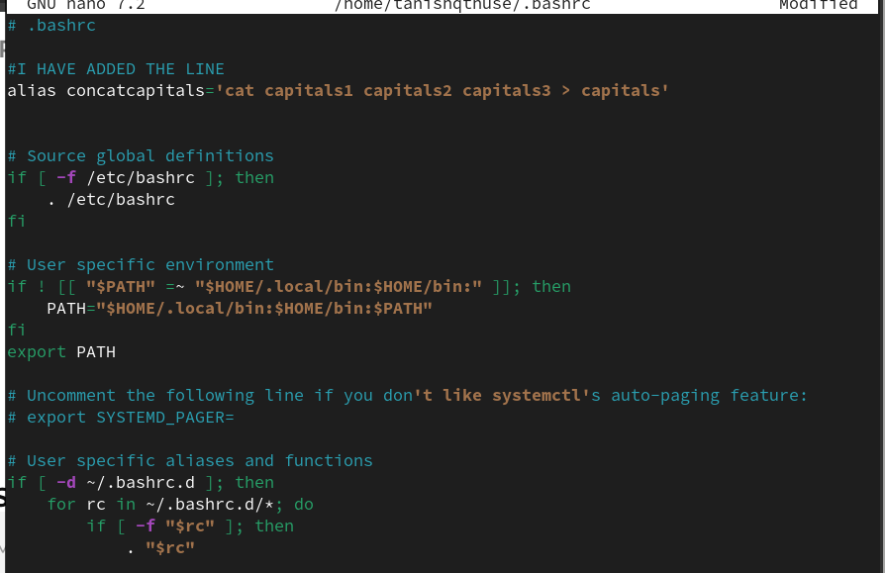

**Q22)Find out the number of times the string “the” appears in the file mydate.**

**Command : grep -o -i "the" mydate | wc -l**

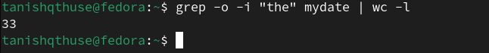

**Q23)Find out the line numbers on which the string “date” exists in mydate.**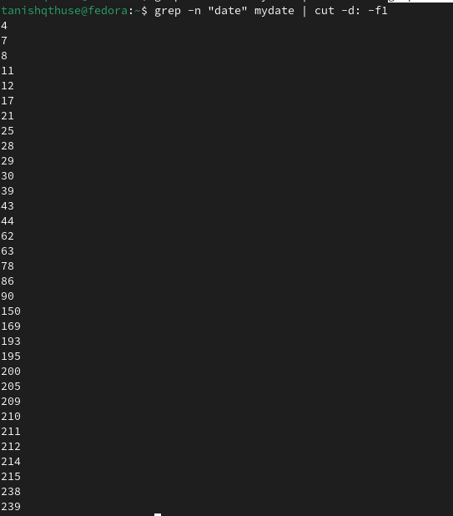

**Q24)Print all lines of mydate except those that have the letter “i” in them.**

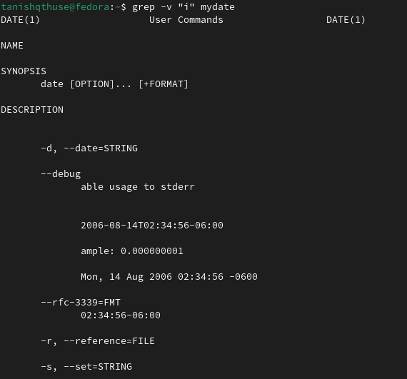

**Q25)List the words of 4 letters from the file mydate.**

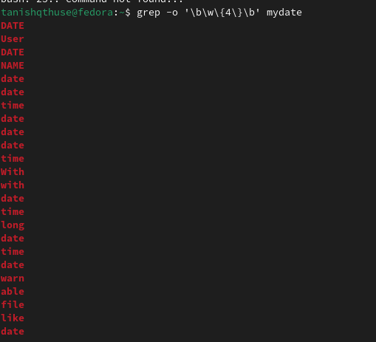

**Q26)List 5 states in north east India in a file mystates. List their corresponding capitals in a filemycapitals. Use the paste command to join the 2 files.**

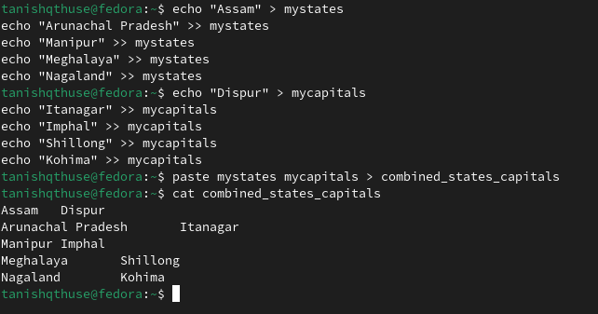

**Q27)27. Use the cut command to print the 1 st and 3 rd columns of the /etc/passwd file for all students**

**in this class.**

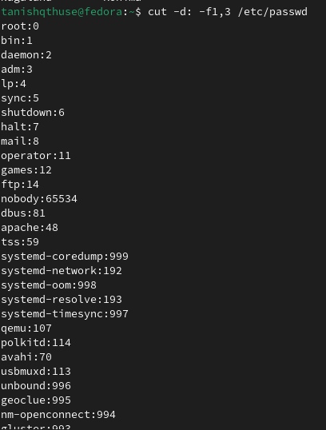

**Q28)Count the number of people logged in and also trap the users in a file using the tee command.**

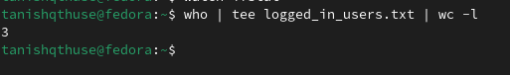

**Q29)Convert the contents of mystates into uppercase.**

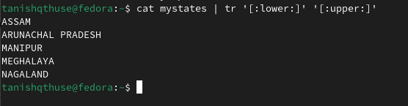

**Q30)Create any two files & display the common values between them.**

